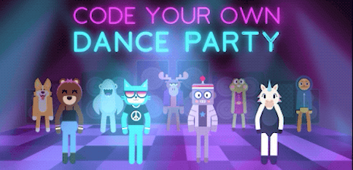

Step 1

In this step you have to make a dancer appear on the screen. You can do this by moving the red “make a new” block and connect it inside the “setup” button.
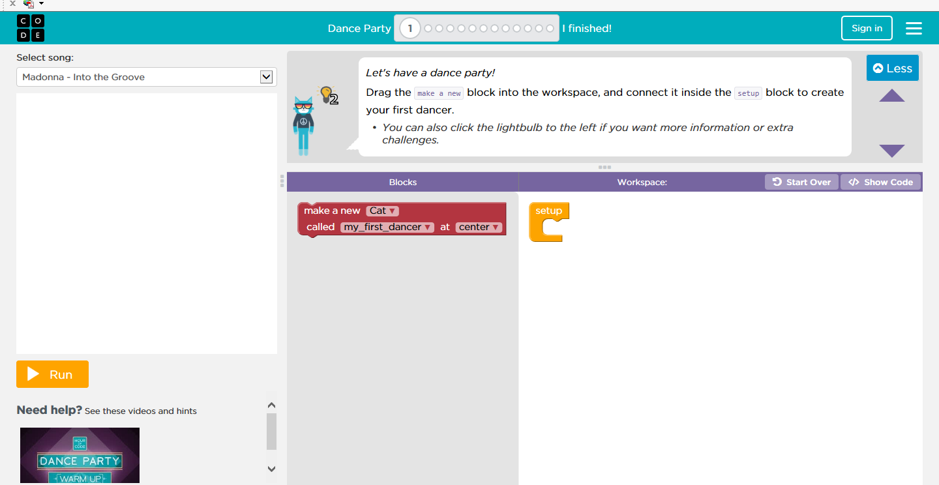

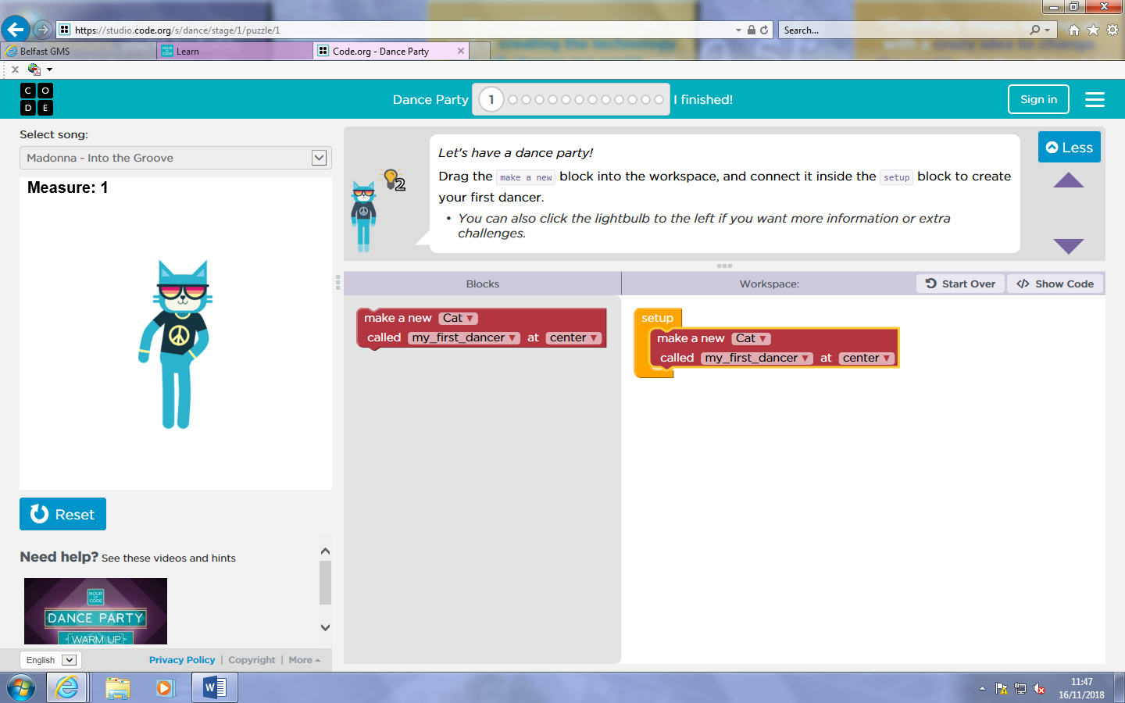
After you have done this click on the “run” button and watch a character appear on the screen!!

Step 2
In this step you get to discover a new character, to do this you need to move the purple “new dancer” block and place it underneath the green “after” block.
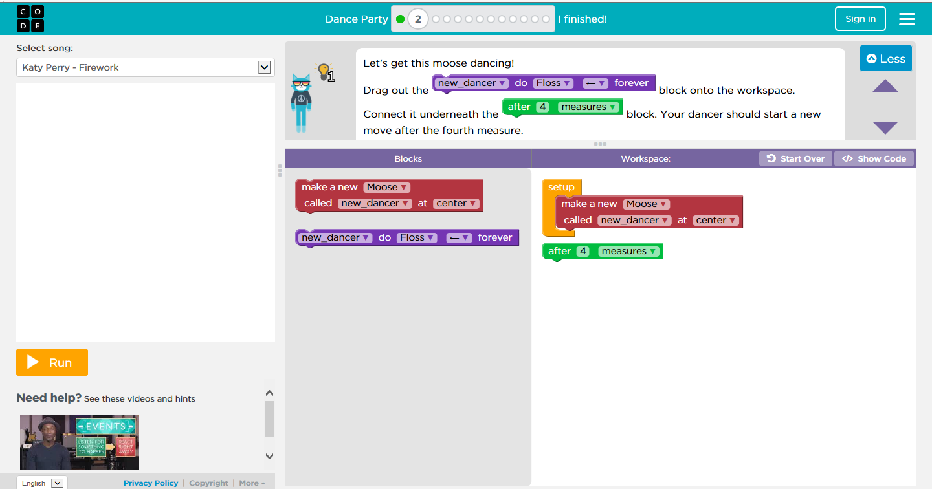

After you have done this click on the “run” button and watch a moose appear dancing to the dance you have chosen!!

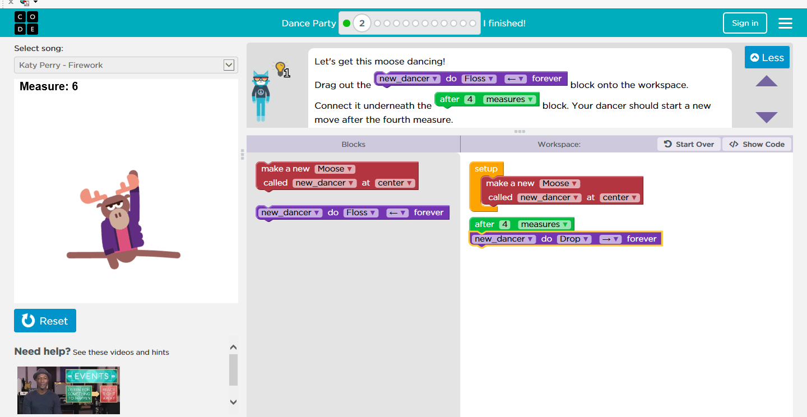

Step 3
In this step you need to add an extra dance move in, you can do this by moving the green “after” block into your workspace and also moving the purple “ducky” block under the “after” block. You can chose what dance you would like to pick!
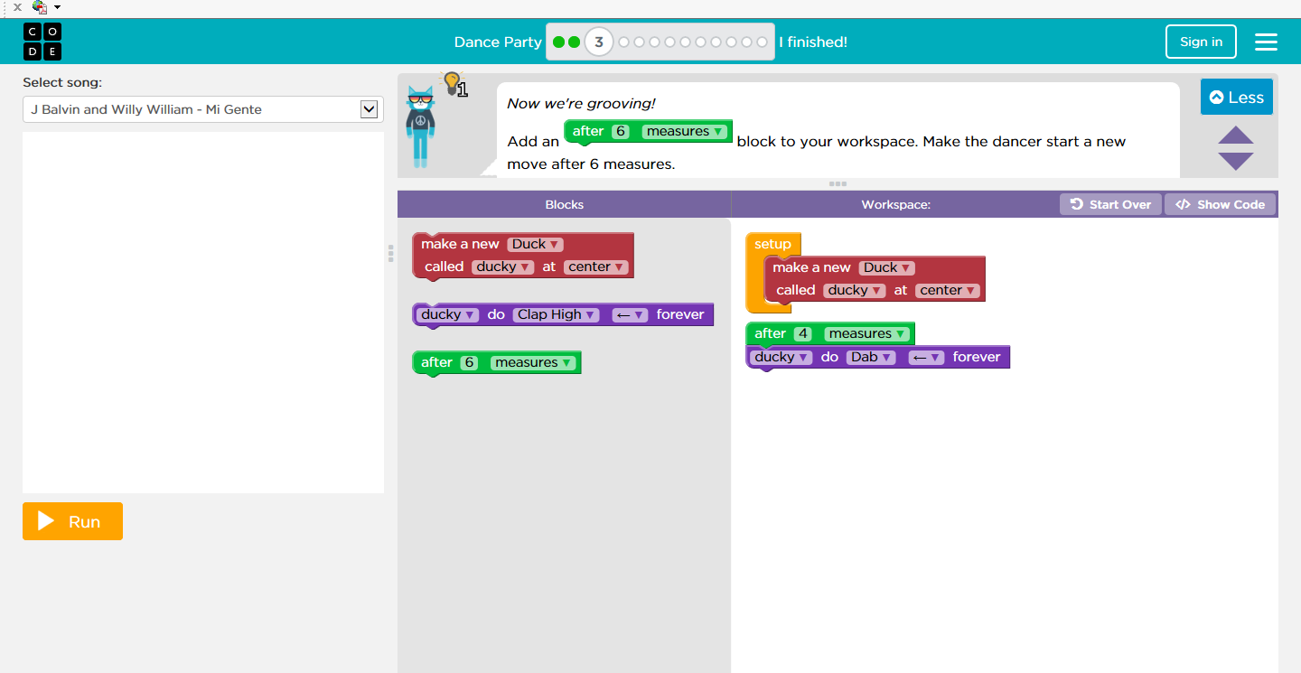

Once you have done this click on the “run” button and watch the duck change his dance moves after 6 measures!!
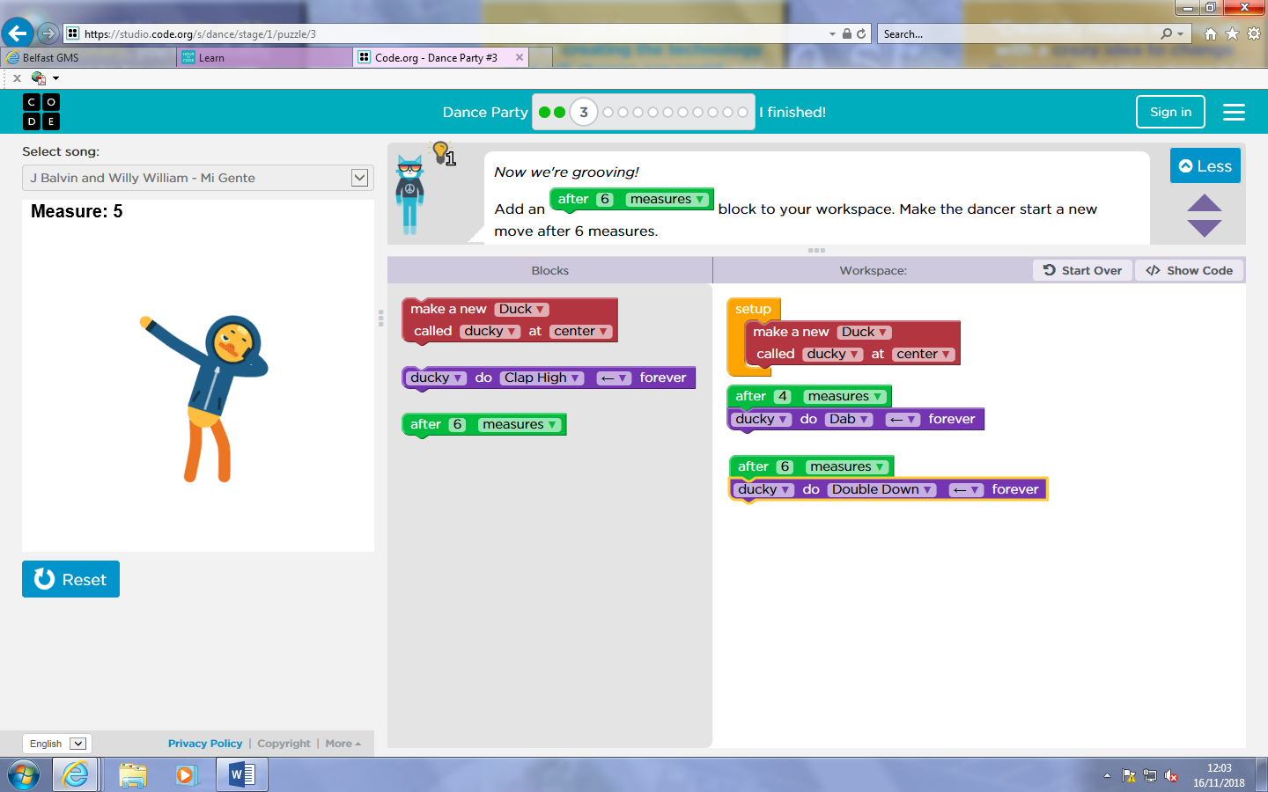
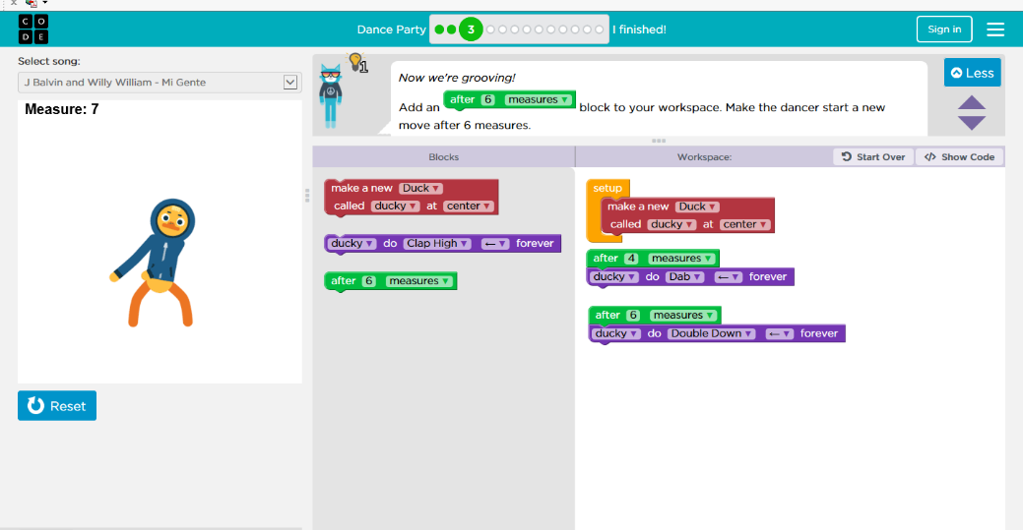
In this step you have to add a background for the dancers, you can do this by moving the blue “set background effect” button below the purple “fancy dancer” button!
Step 4
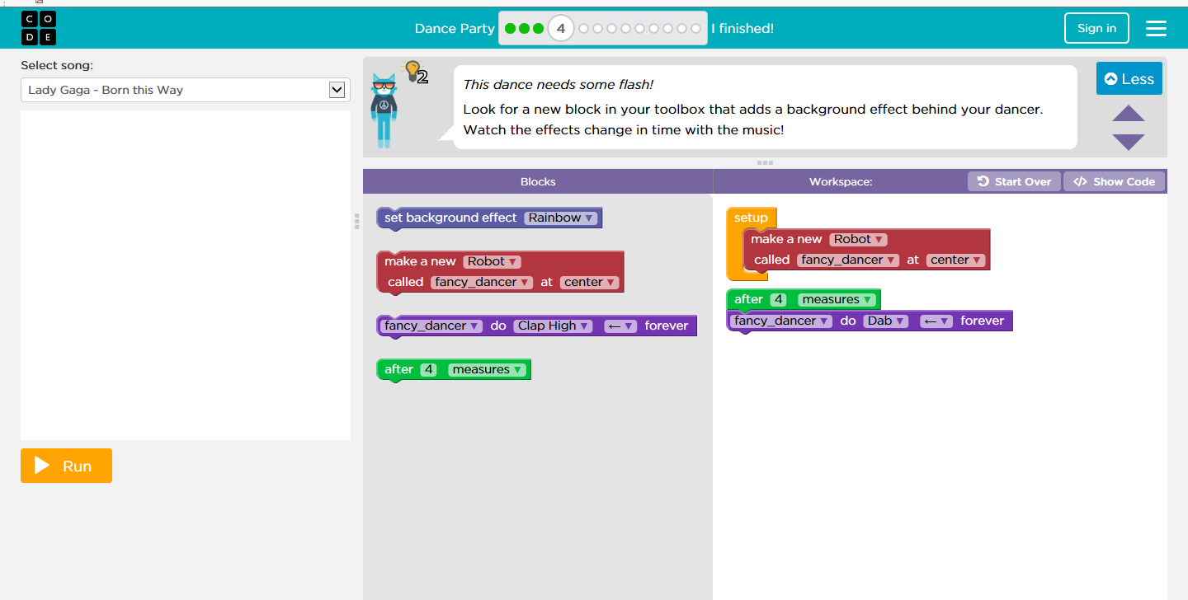

After you have chosen your background click on the “run” button and watch a background appear while your character is dancing!!
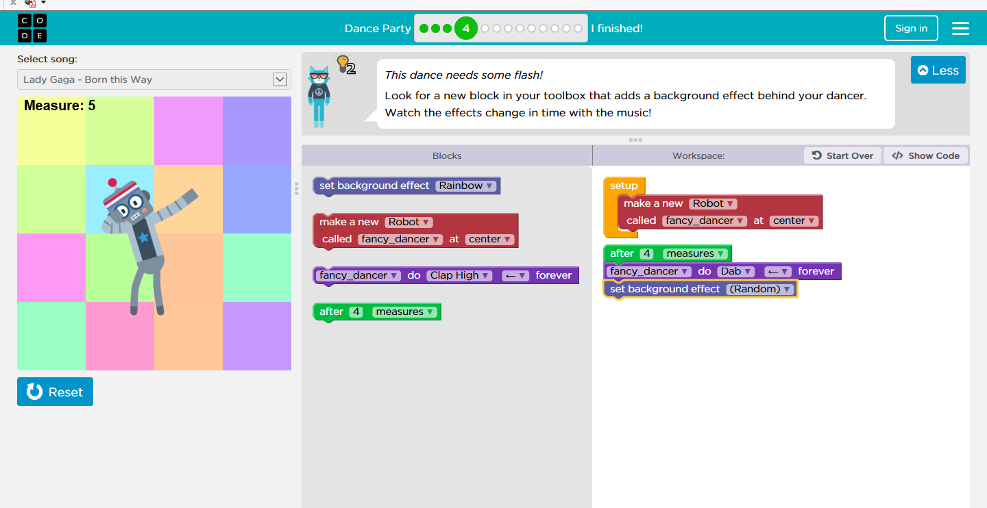
Step 5
In this step you have to make the dancer change every 2 steps, you can do this by moving the pink “every” button and place the purple “crazy cat” inside it!
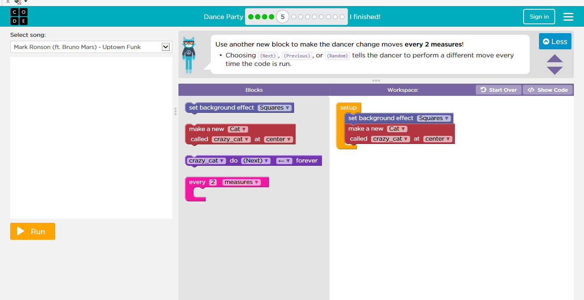

Once you have done this click on the “run” button and watch the cat change his dance moves every 2 measurements!!
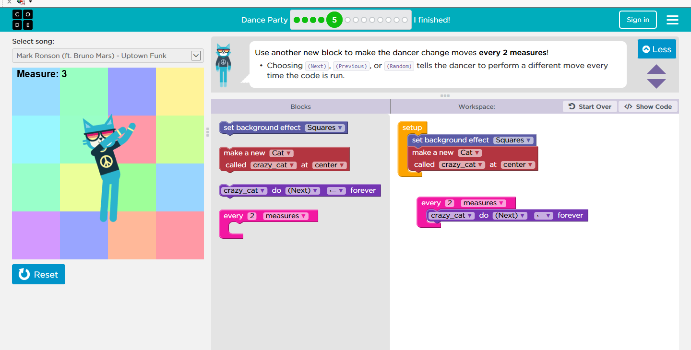

In this step you need to create a backup dancer, you can do this by moving the red “make a new” button and place it under the same red button in the workspace. Also move the purple “backup dancer” underneath the purple “lead dancer” button.
Step 6
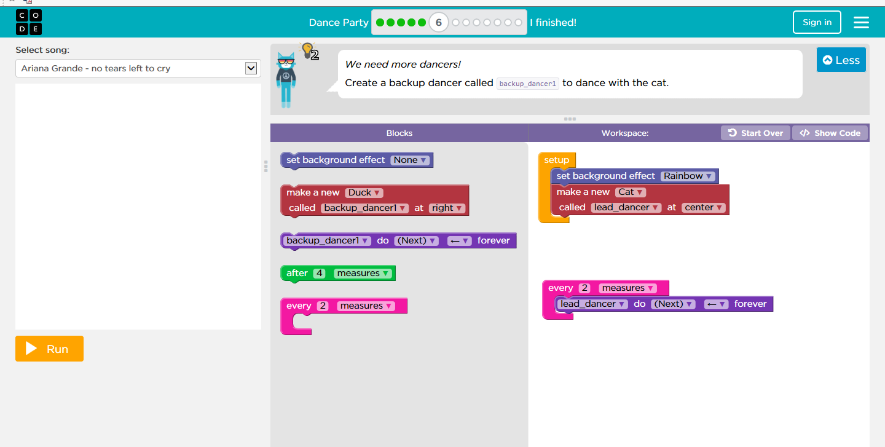

After you have done this click on the “run” button and watch the 2 characters up dancing!!

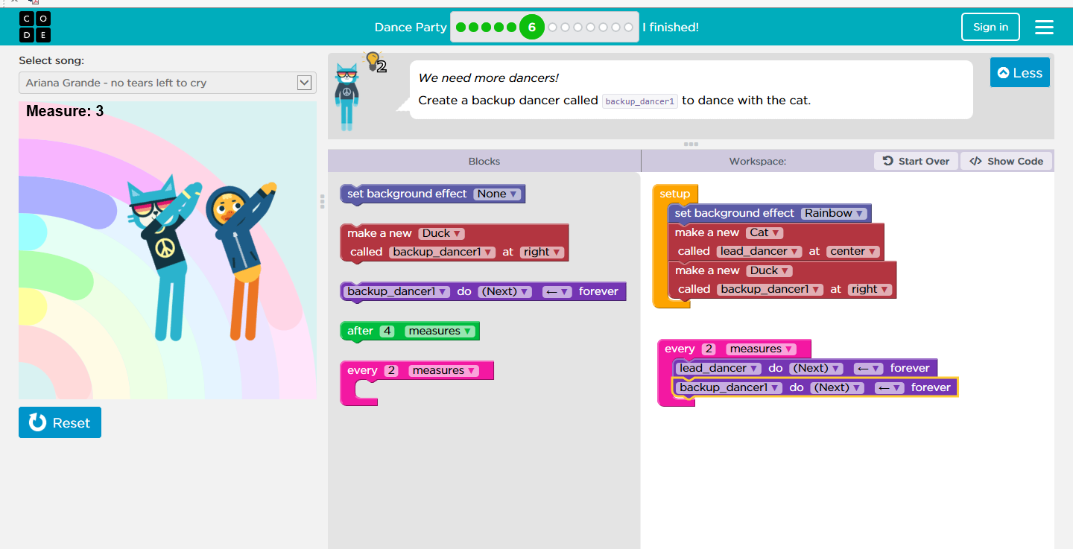
In this step you can change the size of the characters, you can do this by moving the light blue “set” button and move it under the red “make a new” buttons. You can change the sizes of the characters if you want.
Step 7
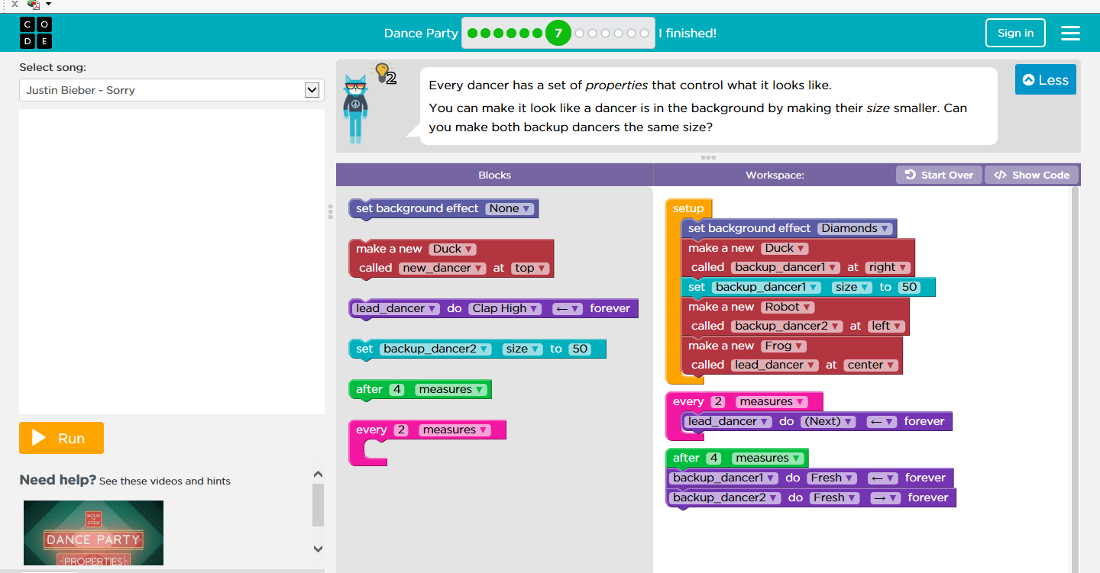

After you have done this click on the “run” button and watch as the dancers appear and the backup dancers become smaller.

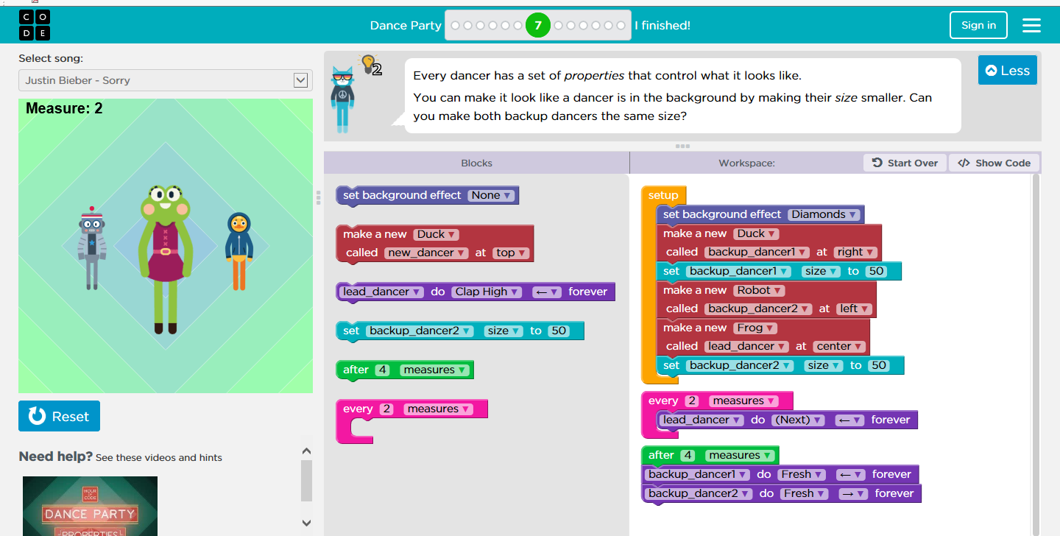
Step 8
In this step you have to change the colour of the dancer by moving the blue “tint” button underneath the orange “setup” button.

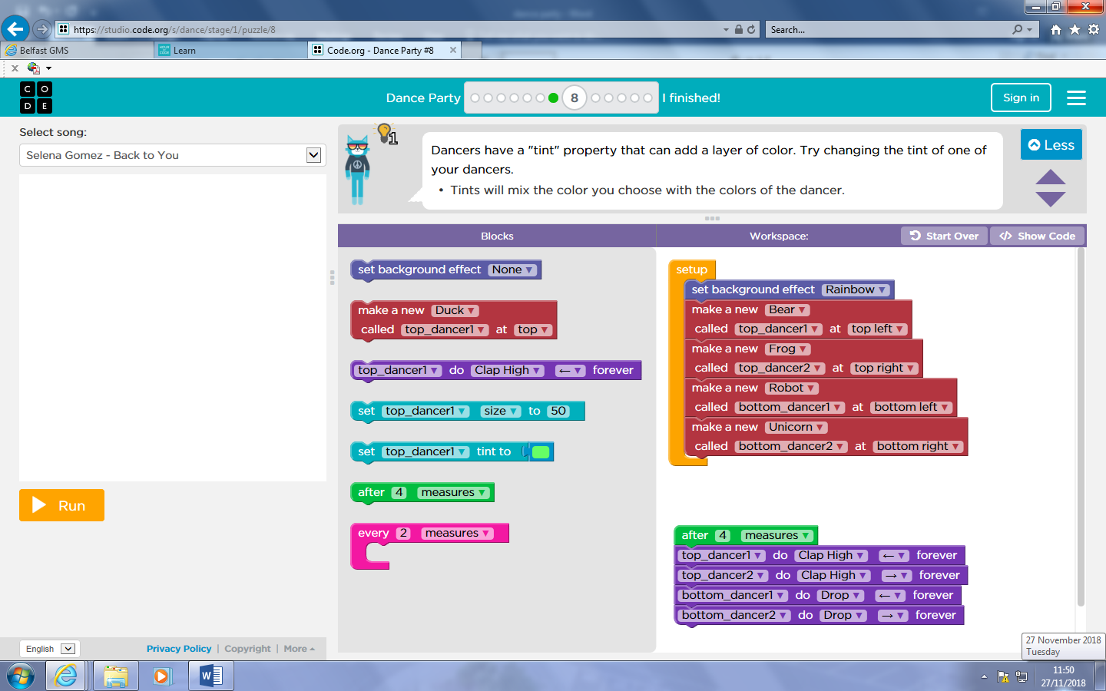
D
After you have done this click on the “run” button and watch the choosen character change colour.
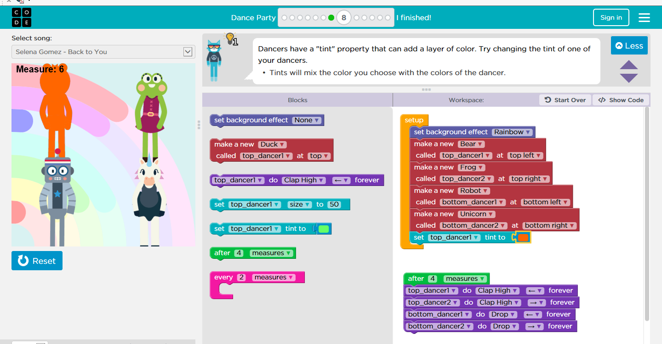

Step 9

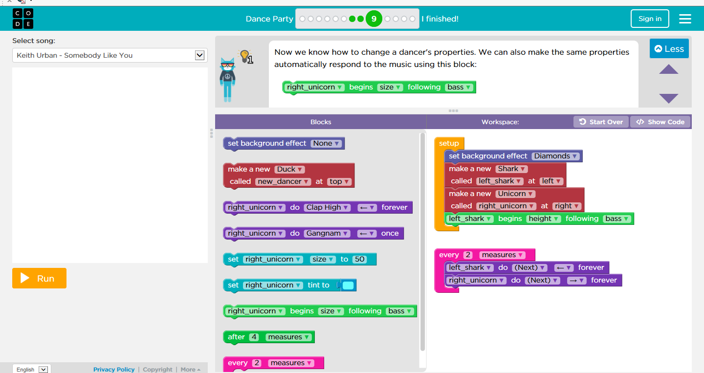
In this step you have to change the size of the unicorn that is dancing. You can do this by moving the green “set unicorn” underneath the green “left_shark” button.

D

Once you have done this click onto the “run” button and watch as both of the dancers change size.
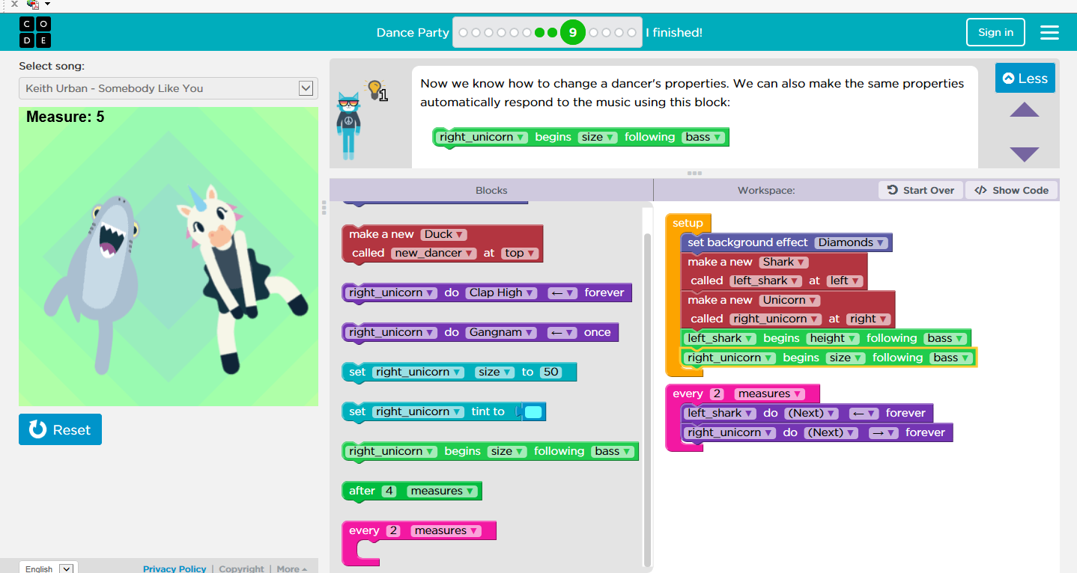

Step 10
In this step you have to add a new dancer by pressing an arrow button. You can do this by moving the red “make a new” button and moving it underneath the green “when pressed” button.
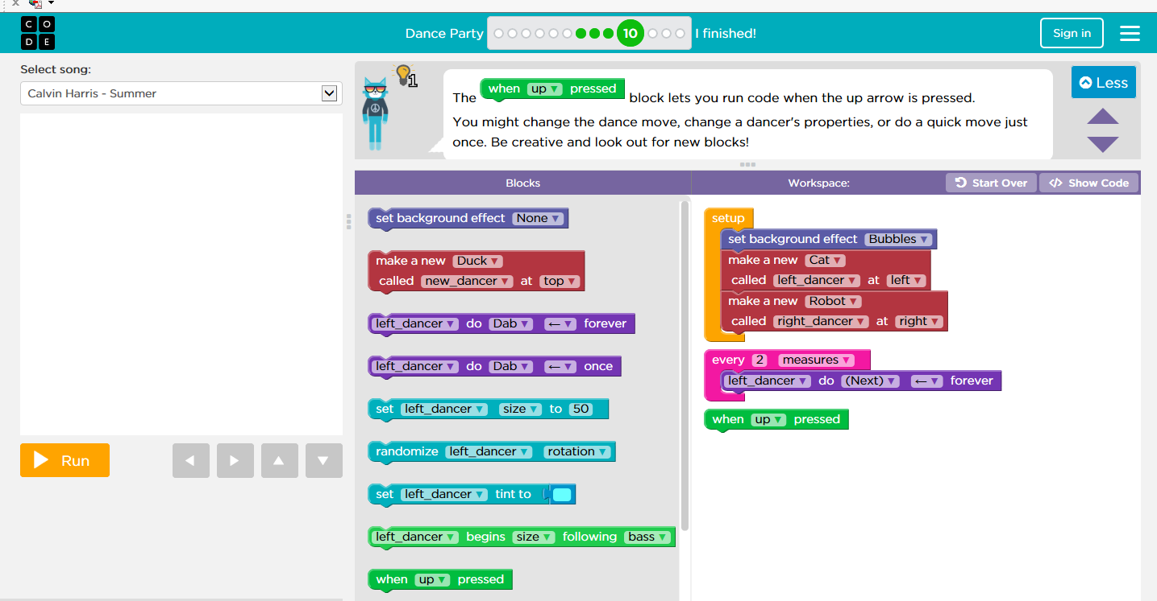

Once you have done this click onto the “run” button, after this press on the arrow at the bottom of the screen and watch your chosen character appear.

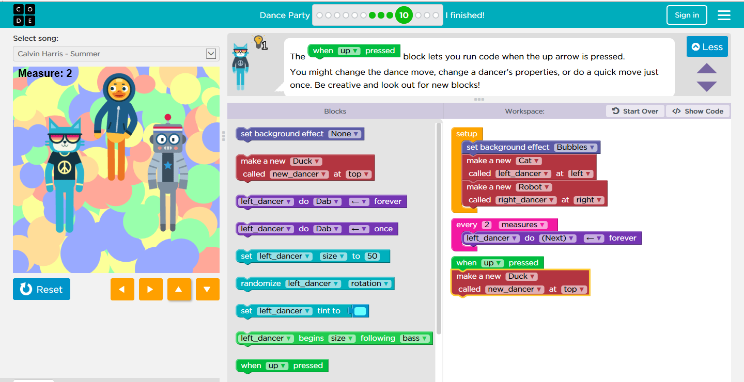

Step 11

In this step you have to control the dancers by pressing certain arrows. To do this move the purple “once” button and move it underneath the green “when right pressed” button. Also move the same purple button and move it underneath the green “when up pressed”. Make sure you change the dance before clicking the “run” button.
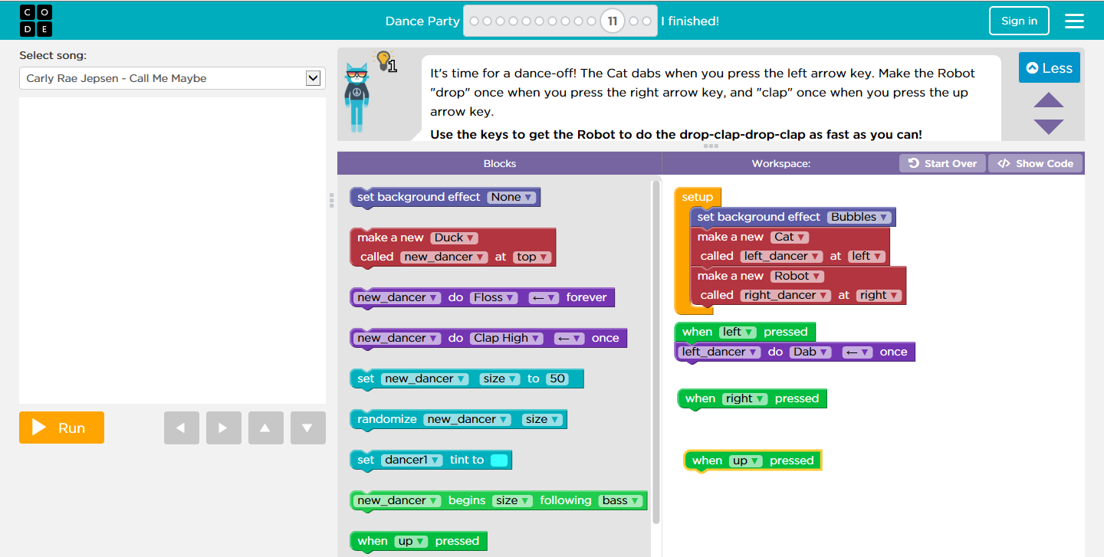

After you have done this click on the “run” button and then press the right, up and left arrows, this will now make your characters dance whenever you press the arrow keys.
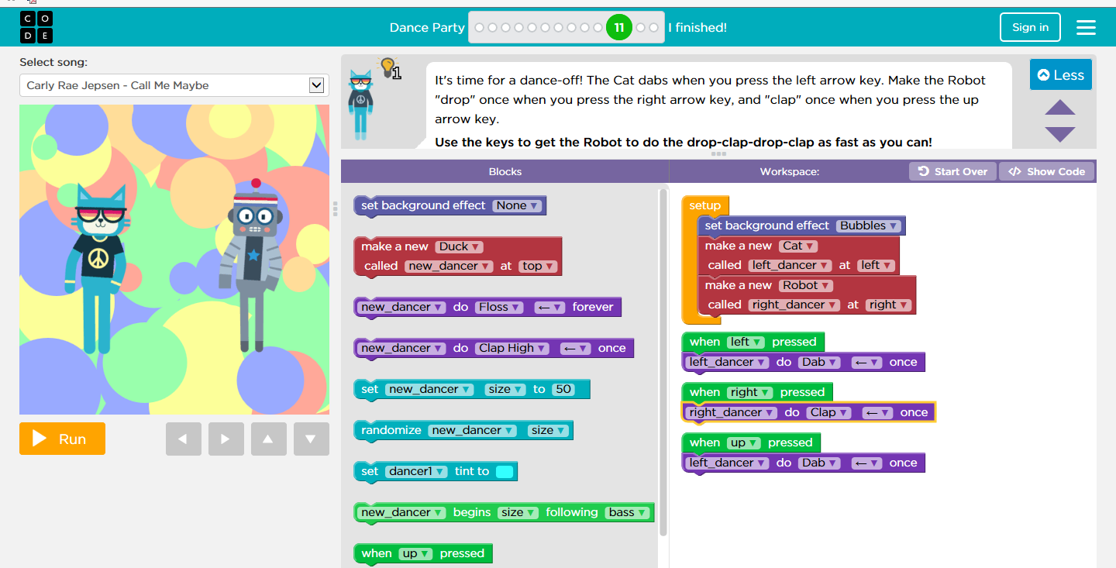

Step 12
In this step you just have to click on the “run” button, and watch what the red “make” button does.
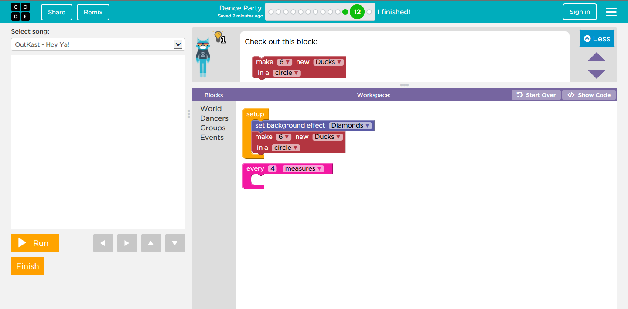

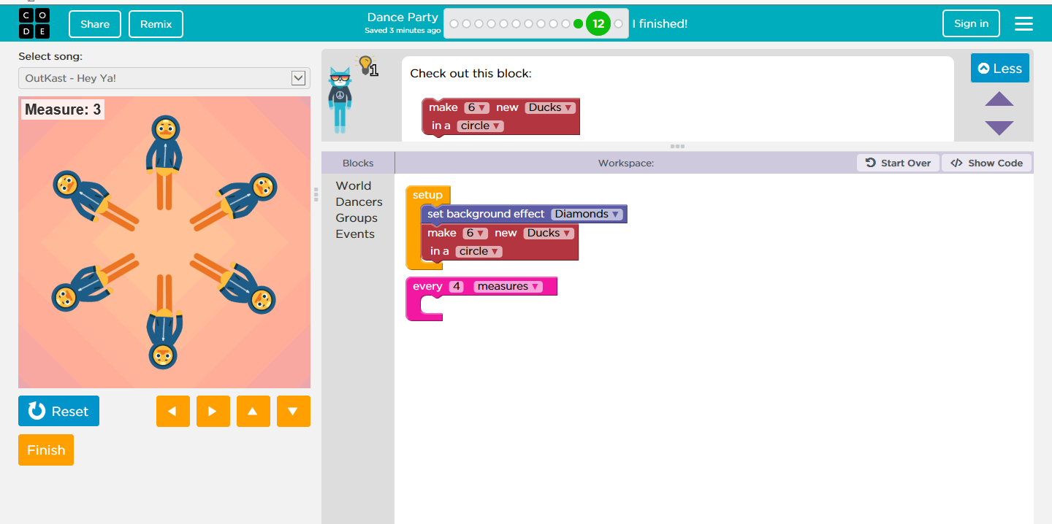

Step 13

In this final step all you have to do is create your own game. You can go crazy, add as much as you want.
Here are some tips that you can use to help you:
- Add backup dancers
- Change the background
- Let the dancers form a shape
- Add effects (rain, tacos etc…)
- Change the song
- Add as many dance moves as you want
- Change the beat!
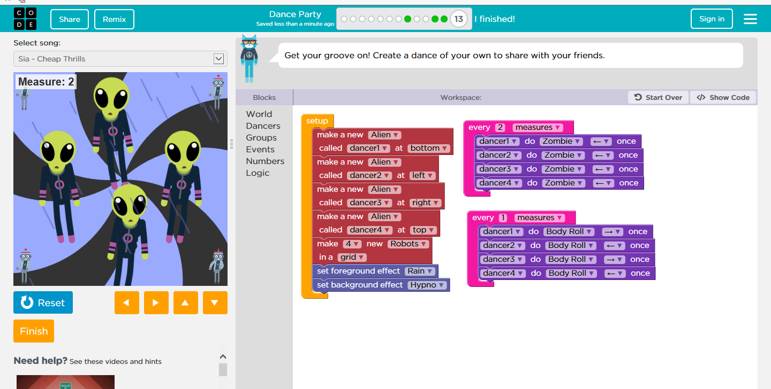

Well done you have completed the hour of code dance party!!!!

