
Sending an Email

Step 1:

Click on the Gmail button on the Virtual GMS page.
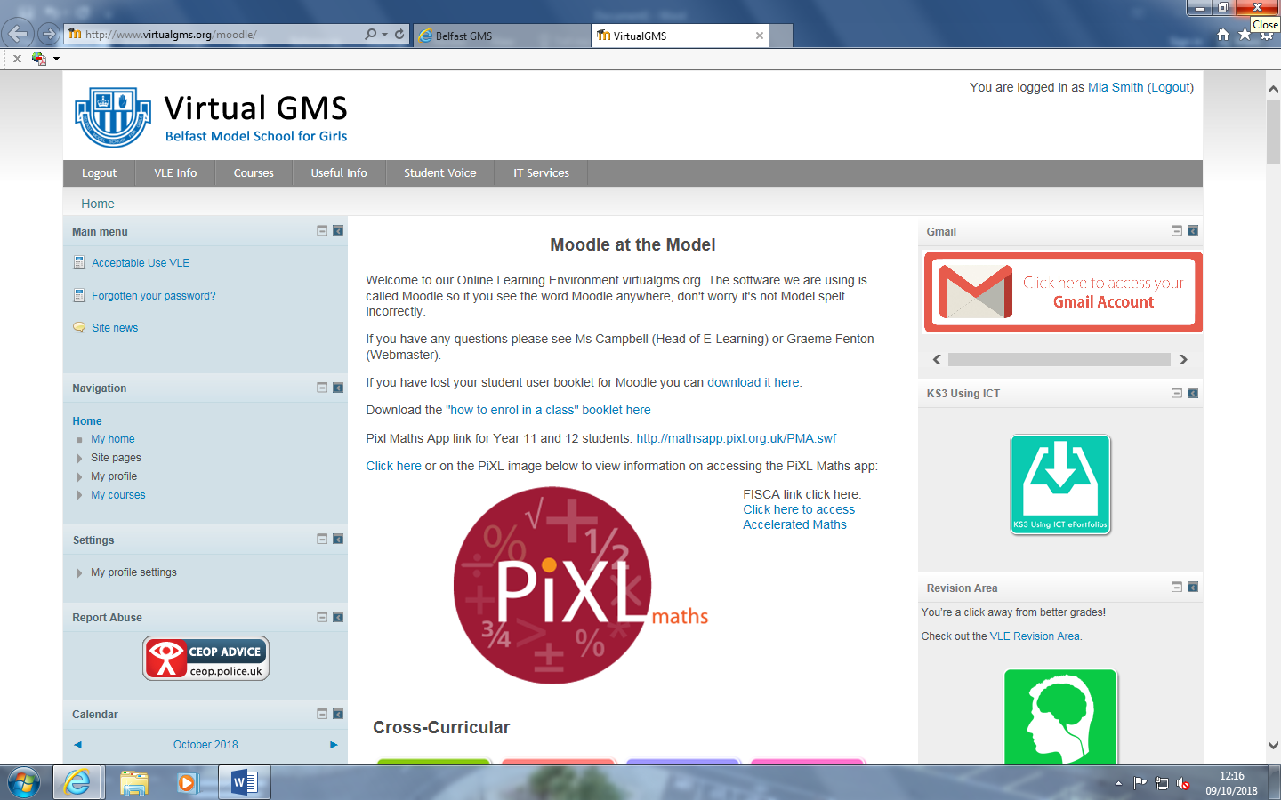

Step 2:

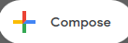
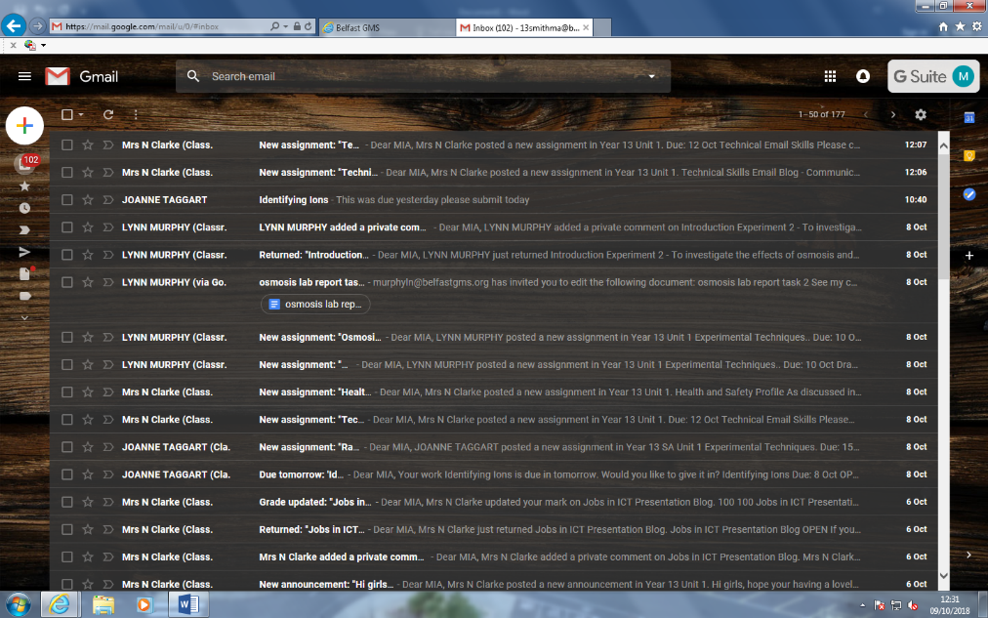
Once the Gmail page comes up, click on the compose button. Compose means to write or create so this is where you will write your email.

Step 3:
Once a new Email window appears click on the “to” button and type the recipient you want to send the email to. You are going to be sending your email to Mrs Clarke.
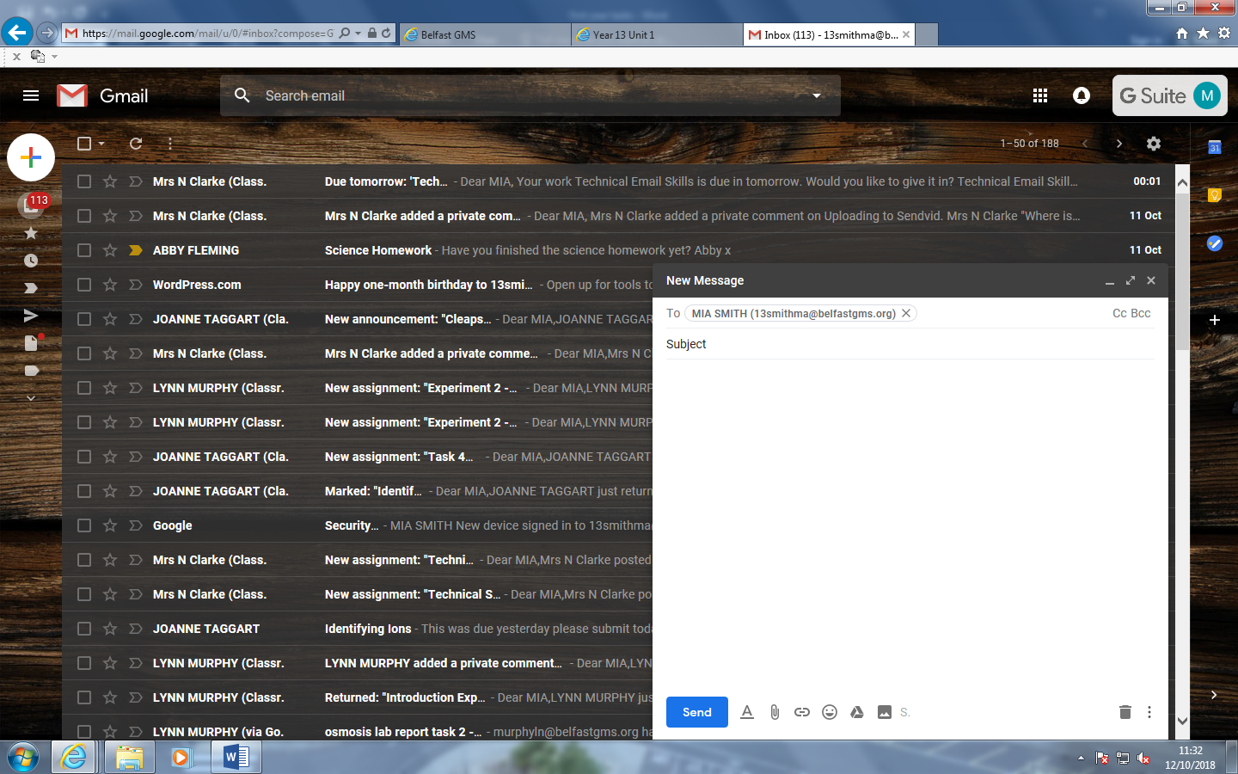

Step 4:

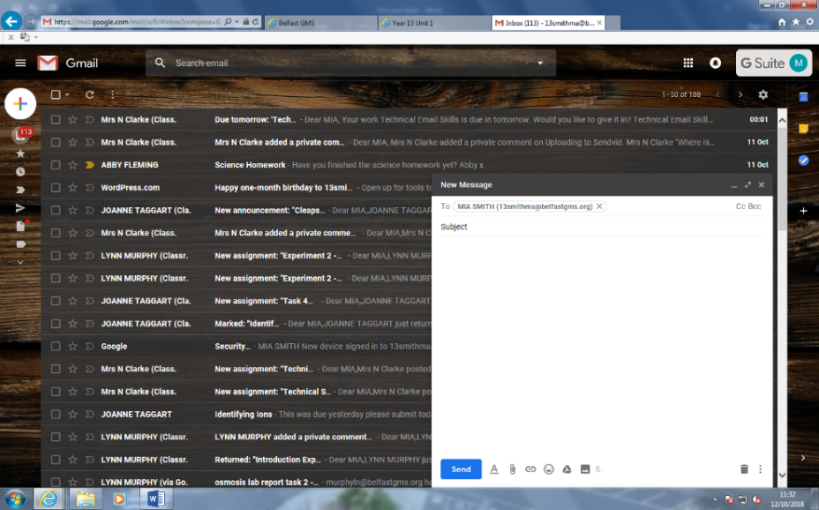
In the subject box, write what the email will be about. The subject is very important and should never be left blank as this tells you what the email will be about.

Step 5:
Move your mouse to the window below the subject box and begin to write your email. Make sure there is no inappropriate language as the head of ICT will be notified.

Write your email in here!

Step 6:

Once you have typed and checked your email click send.
You have now sent an e-mail well done!
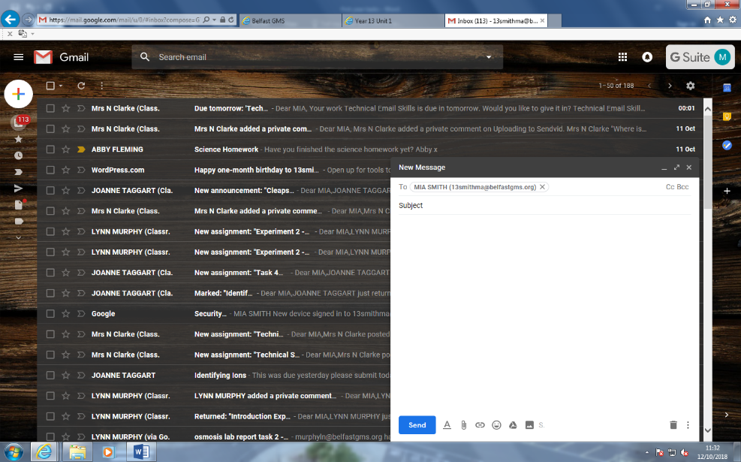
Your email will be here!
E


Replying to an email

Step 1:

Click on the email you want to reply to.
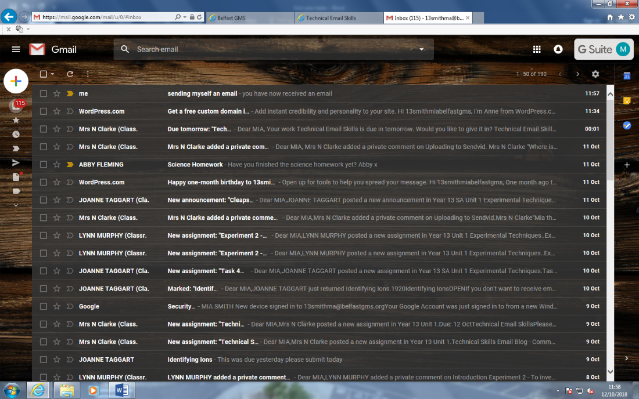

Step 2:

Once you have clicked on the email, click on the reply button. Reply means to say something in response to something someone has said.
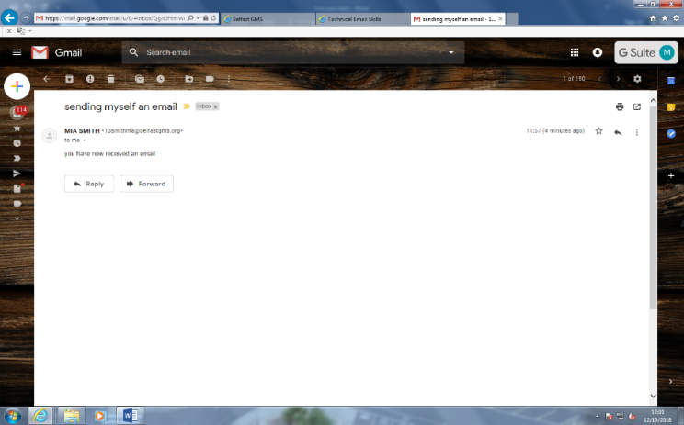

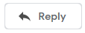
Step 3:

iidu
A screen will be displayed to allow you to write the blurb. Make sure not to use any inappropriate language as the head of ICT will see this.
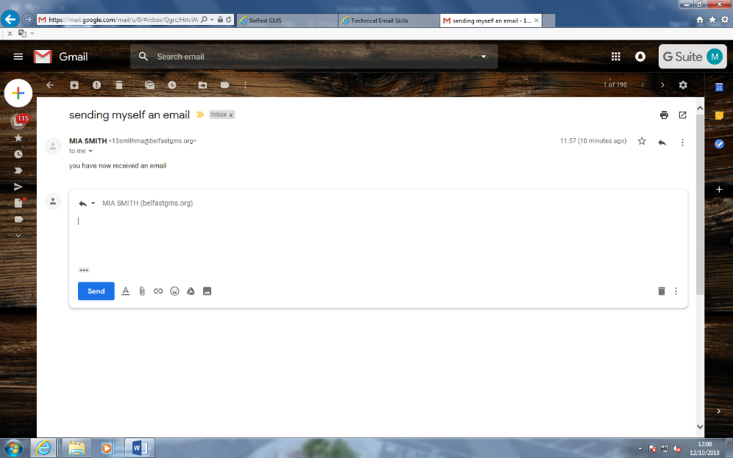

Your reply will be in here!

Step 4:

iidu

Once you have finished writing your reply, just click the send button. Then you have replied to an email.
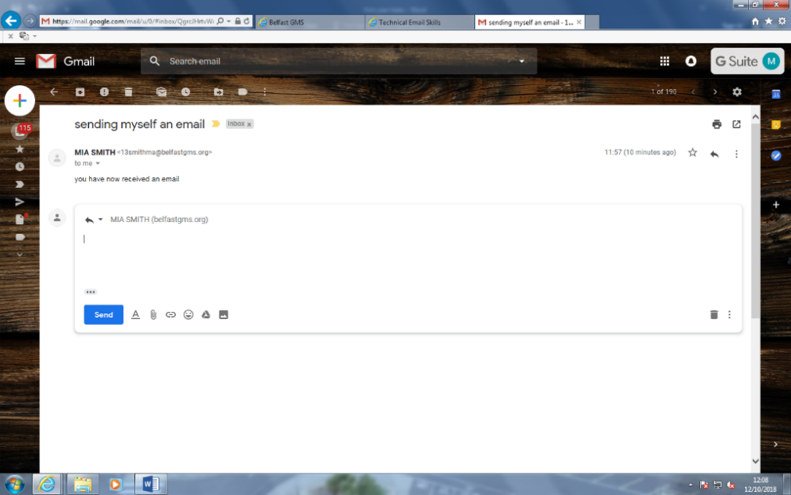


Forwarding an email

Step 1:

Click on the email you want to forward. Forwarding an email means to resend the exact same email.
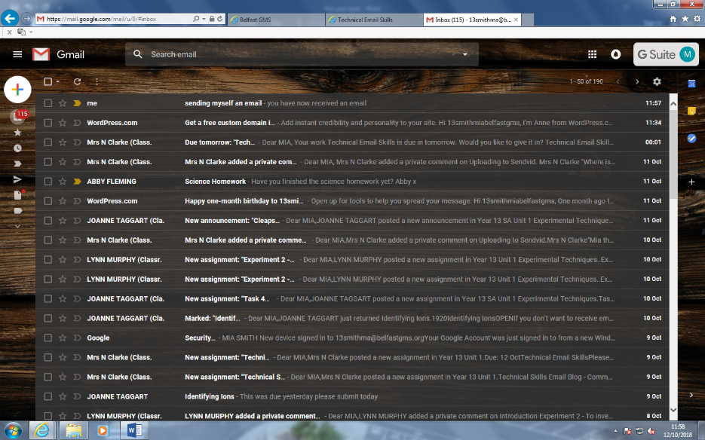

Step 2:

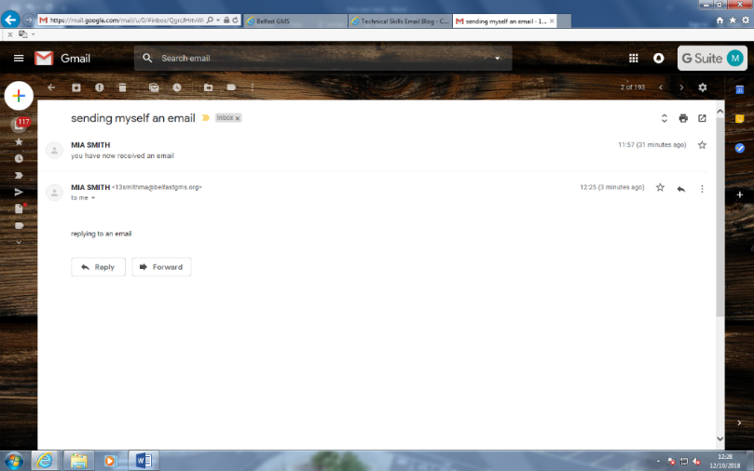
Once you click onto the email a new window will appear you then click onto the forward button below.

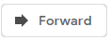

Step 3:

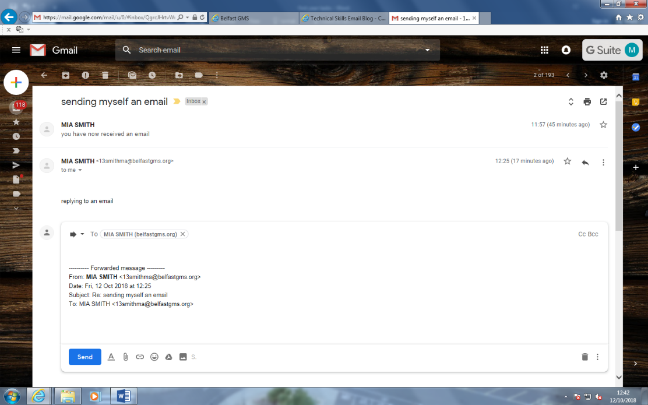
Once you have clicked on the forward button, write in the “to” box who you are forwarding the email to.

Step 4:

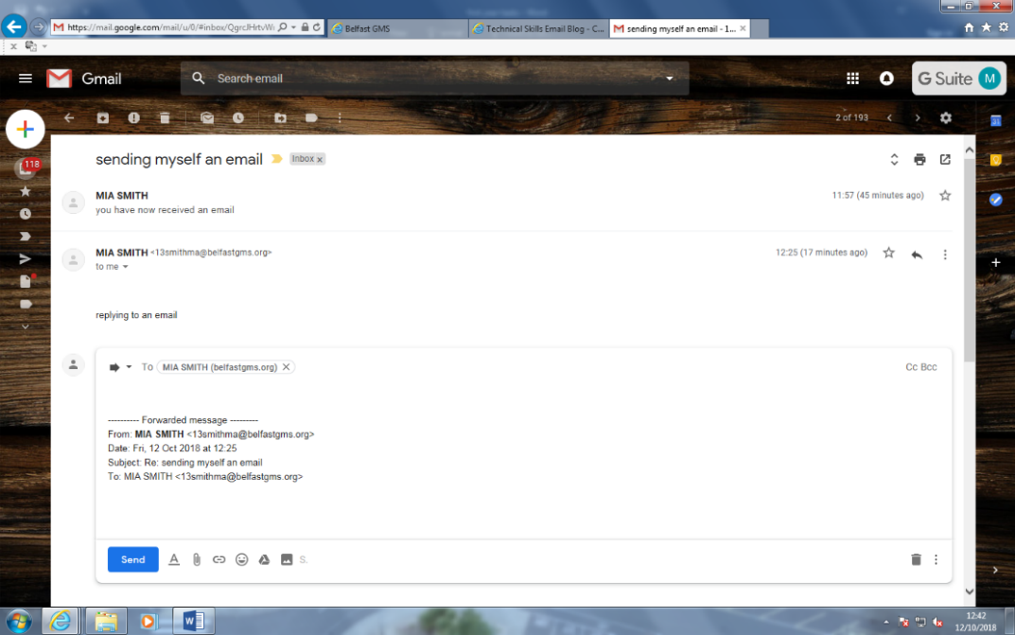
You then text what you want to say in the email, make you be careful with what you say as the head of ICT can see what you type.

Your email goes in here!

Step 5:

Once you have finished writing the email just click the send button. You have now forwarded an email. Well done!

by


Attaching a file
Step 1:

- Click onto the compose button and type who you want to send an email to. Attaching an email means an extra part or extension that is or may be attached to something to perform a particular function.

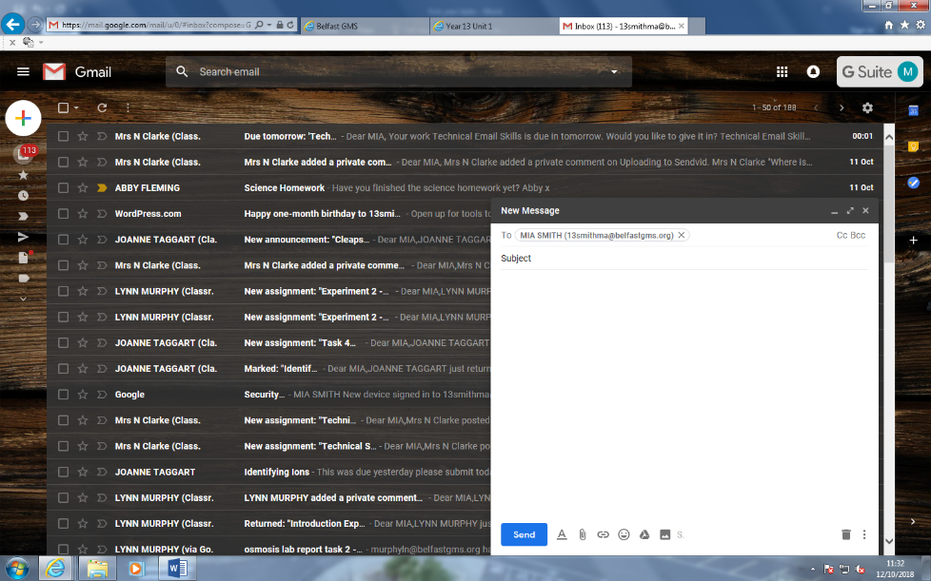

Step 2:

Next you click onto the paperclip icon to add an attachment to the email



Step 3:

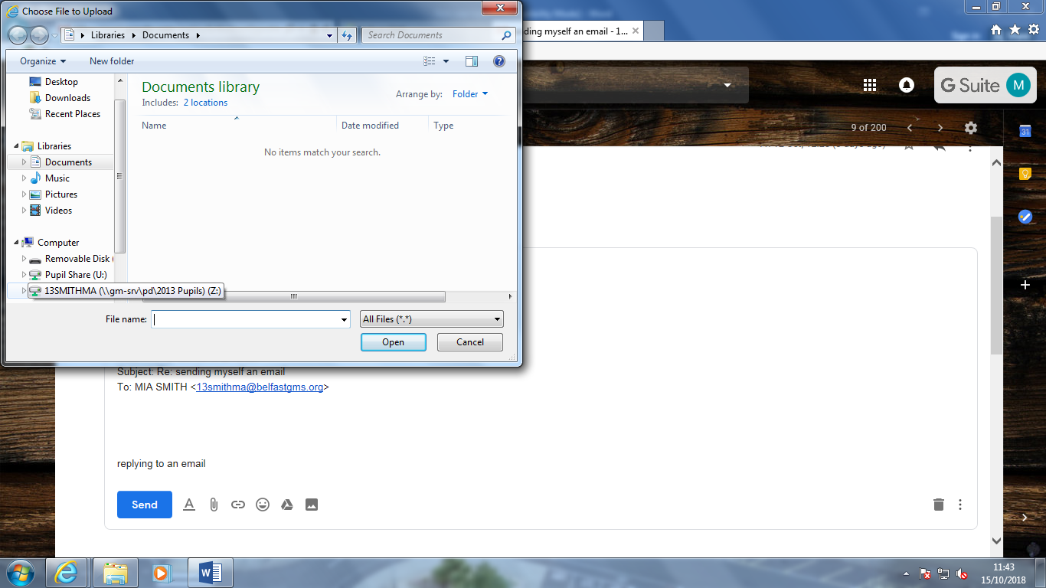
Once this screen appears click onto your area and find what you want to attach in your year 8 folder.

Step 4:
Step4 44:

You can then see your attachment once you are happy click the send button and that’s you finished!
